Lab: Complex Conditional Statements
Test your tasks in the Judge system: https://judge.softuni.org/Contests/4398

Marketplace
Write a program that:
- Reads two strings from the console: product (string) and day (string).
- Print the price, formatted to the second digit, based on the price table:
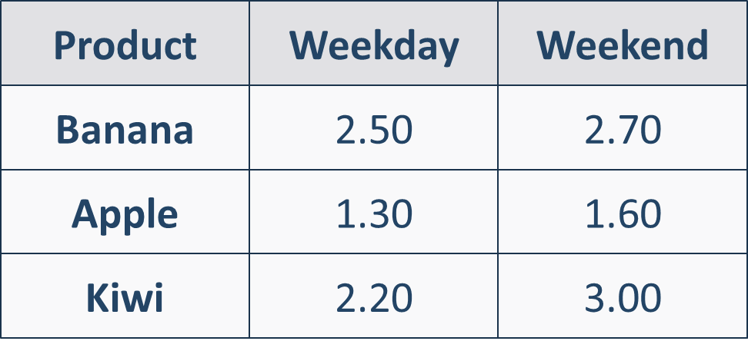

Example
Input | Output |  | Input | Output |  | Input | Output
Kiwi  Weekday | 2.20 |  | Banana  Weekend | 2.70 |  | Apple  Weekend | 1.60

Guidelines
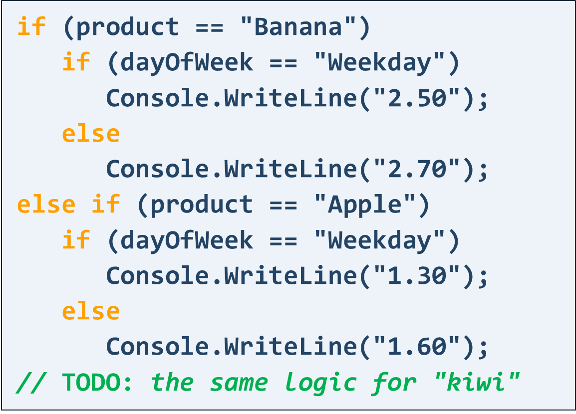

Largest Number Out of Three
Write a program that:
- Reads 3 integer numbers from the console
- Prints the largest number

Example
Input | Output |  | Input | Output |  | Input | Output
1  2  3 | 3 |  | -1  -5  -9 | -1 |  | 6  9  10 | 10

Guidelines
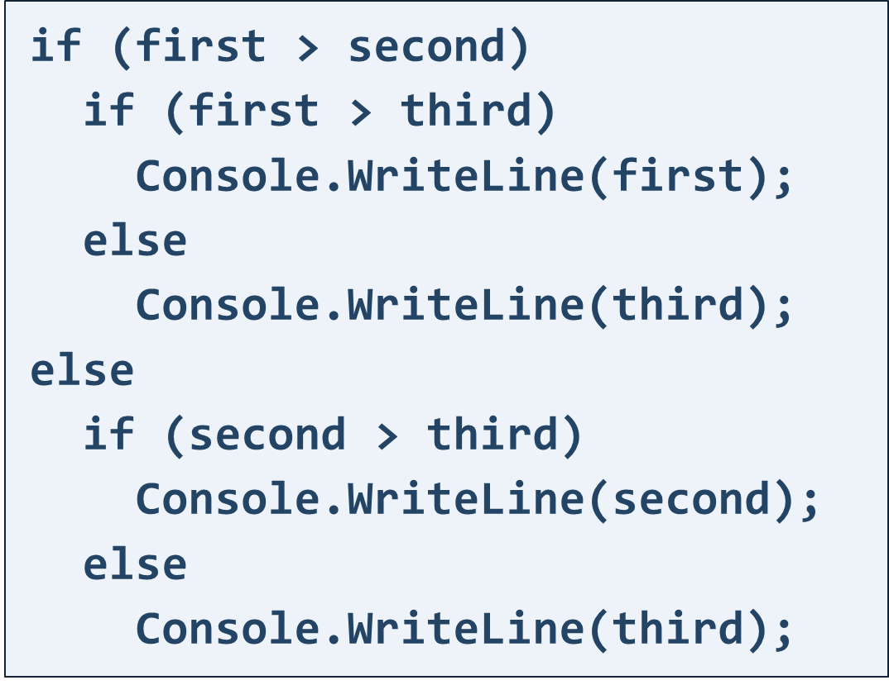

Bonus Score
Write a program that:
- Reads points (integer number) from the console
- Add bonus points to given points based on following:
  - If points are between 0 and 3 (inclusive), adds 5 to the given points
  - If points are between 4 and 6 (inclusive), adds 15 to the given points
  - If points are between 7 and 9 (inclusive), adds 20 to the given points
- Print final points after adding the bonus points

Example
Input | Output | Comments
1 | 6 | The given points are with value: 1  This value is between 0 and 3, so we add 5 points to the given points:  1 + 5 = 6
4 | 19 | The given points are with value: 4  This value is between 4 and 6, so we add 15 points to the given points:  4 + 15 = 19

Food or Drink
Write a program that:
- Reads a product (string) from the console
- Based on type of the given product, print:
  - If product is one of following "curry", "noodles", "sushi", "spaghetti" or "bread" you have to print "food"
  - If product is one of following "tea", "water", "coffee" or "juice" you have to print "drink"
  - If the product is different from listed products above, print "unknown"

Example
Input | Output |  | Input | Output |  | Input | Output
sushi | food |  | water | drink |  | car | unknown

Invalid Number
A given number is valid if it is in the range [100...200] or it is equals to 0.
Write a program that:
- Reads an integer from the console
- Prints "invalid" if the entered number is NOT valid

Example
Input | Output |  | Input | Output |  | Input | Output
75 | invalid |  | 150 | (няма изход) |  | 0 | (няма изход)

Day of Week
Write a program to print the day of week as words, which:
- Reads an integer number (the number will be in range [1… 7]) from the console
- Based on the value of the number, print:
  - If the given number is equals to 1 print the first day of the week, which is "Monday"
  - If the given number is equals to 2 print the second day of the week, which is "Tuesday"
  - If the given number is equals to 3 print the third day of the week, which is "Wednesday"
  - If the given number is equals to 4 print the fourth day of the week, which is "Thursday"
  - If the given number is equals to 5 print the fifth day of the week, which is "Friday"
  - If the given number is equals to 6 print the sixth day of the week, which is "Saturday"
  - If the given number is equals to 7 print the seventh day of the week, which is "Sunday"
  - If the given number is out of the given range print "Error"

Example
Input | Output |  | Input | Output |  | Input | Output
1 | Monday |  | 2 | Tuesday |  | 3 | Wednesday

Input | Output |  | Input | Output |  | Input | Output
4 | Thursday |  | 5 | Friday |  | 6 | Saturday

Input | Output |  | Input | Output |  | Input | Output
7 | Sunday |  | 10 | Error |  | -8 | Error

Vowel or Consonant
Write a program to check a letter for vowel or consonant:
- Reads a character (letter, part of the English alphabet) from the console
- Based on the value of the character, print:
  - If the character is vowel letter print "Vowel"
Hint: Vowels letters are: A, a, E, e, I, i, O, o, U, u
  - If the character is consonant letter print "Consonant"

Example
Input | Output |  | Input | Output |  | Input | Output
a | Vowel |  | A | Vowel |  | E | Vowel

Input | Output |  | Input | Output |  | Input | Output
e | Vowel |  | O | Vowel |  | d | Consonant

Input | Output |  | Input | Output |  | Input | Output
o | Vowel |  | U | Vowel |  | R | Consonant

Sorted Numbers
Write a program, which checks for sorted 3 numbers:
- Reads 3 integer numbers from the console
- Based on the order of the numbers, print:
  - "Ascending" – if the numbers are in ascending order (from the smallest to the largest number)
  - "Descending" – if the numbers are in descending order (from the largest to the smallest number)
  - "Not sorted" – in any other case
Note: Given numbers will not be equal.

Example
Input | Output |  | Input | Output |  | Input | Output
1  2  3 | Ascending |  | 10  9  8 | Descending |  | 3  1  2 | Not sorted

Cinema
Write a program, that calculates the price for all the tickets for a cinema movie:
- Reads the type of the movie (string), the count of the rows (an integer number) and count of the seats per row (an integer number) in the cinema
  - Type of the movie will be one of the following: "Premiere", "Normal" and "Discount"
- Prints the total price for all seats formatted to the 2nd digit after the decimal point, based on the table below:
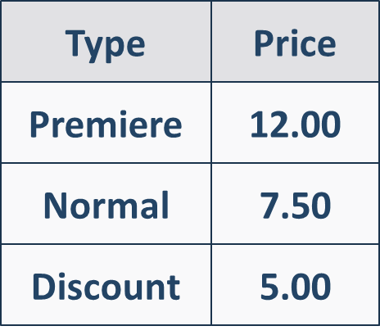

Example
Input | Output | Comments
Normal  12  9 | 810.00 | Type of the movie is Normal and the price for one seat is: 7.50  Total count of the seats in the cinema: 12 * 9 = 108  Total price for all seats: 108 * 7.50 = 810.00
Premiere  10  5 | 600.00 | Type of the movie is Premiere and the price for one seat is: 12.00  Total count of the seats in the cinema: 10 * 5 = 50  Total price for all seats: 50 * 12.00 = 600.00
Discount  10  5 | 250.00 | Type of the movie is Discount and the price for one seat is: 5.00  Total count of the seats in the cinema: 10 * 5 = 50  Total price for all seats: 50 * 5.00 = 250.00

